MODULE 3
1. For Loop in C | HackerRank
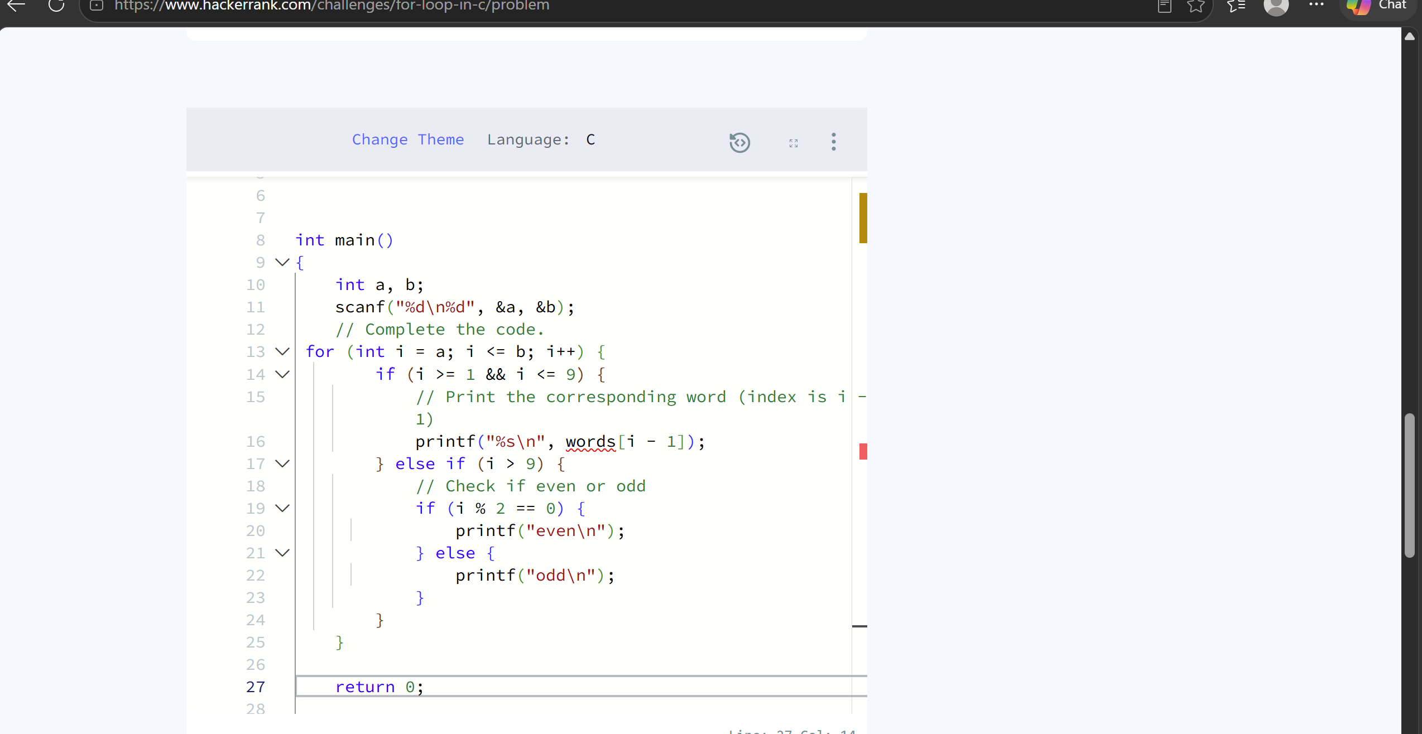
2. Number of Steps to Reduce a Number to Zero - LeetCode
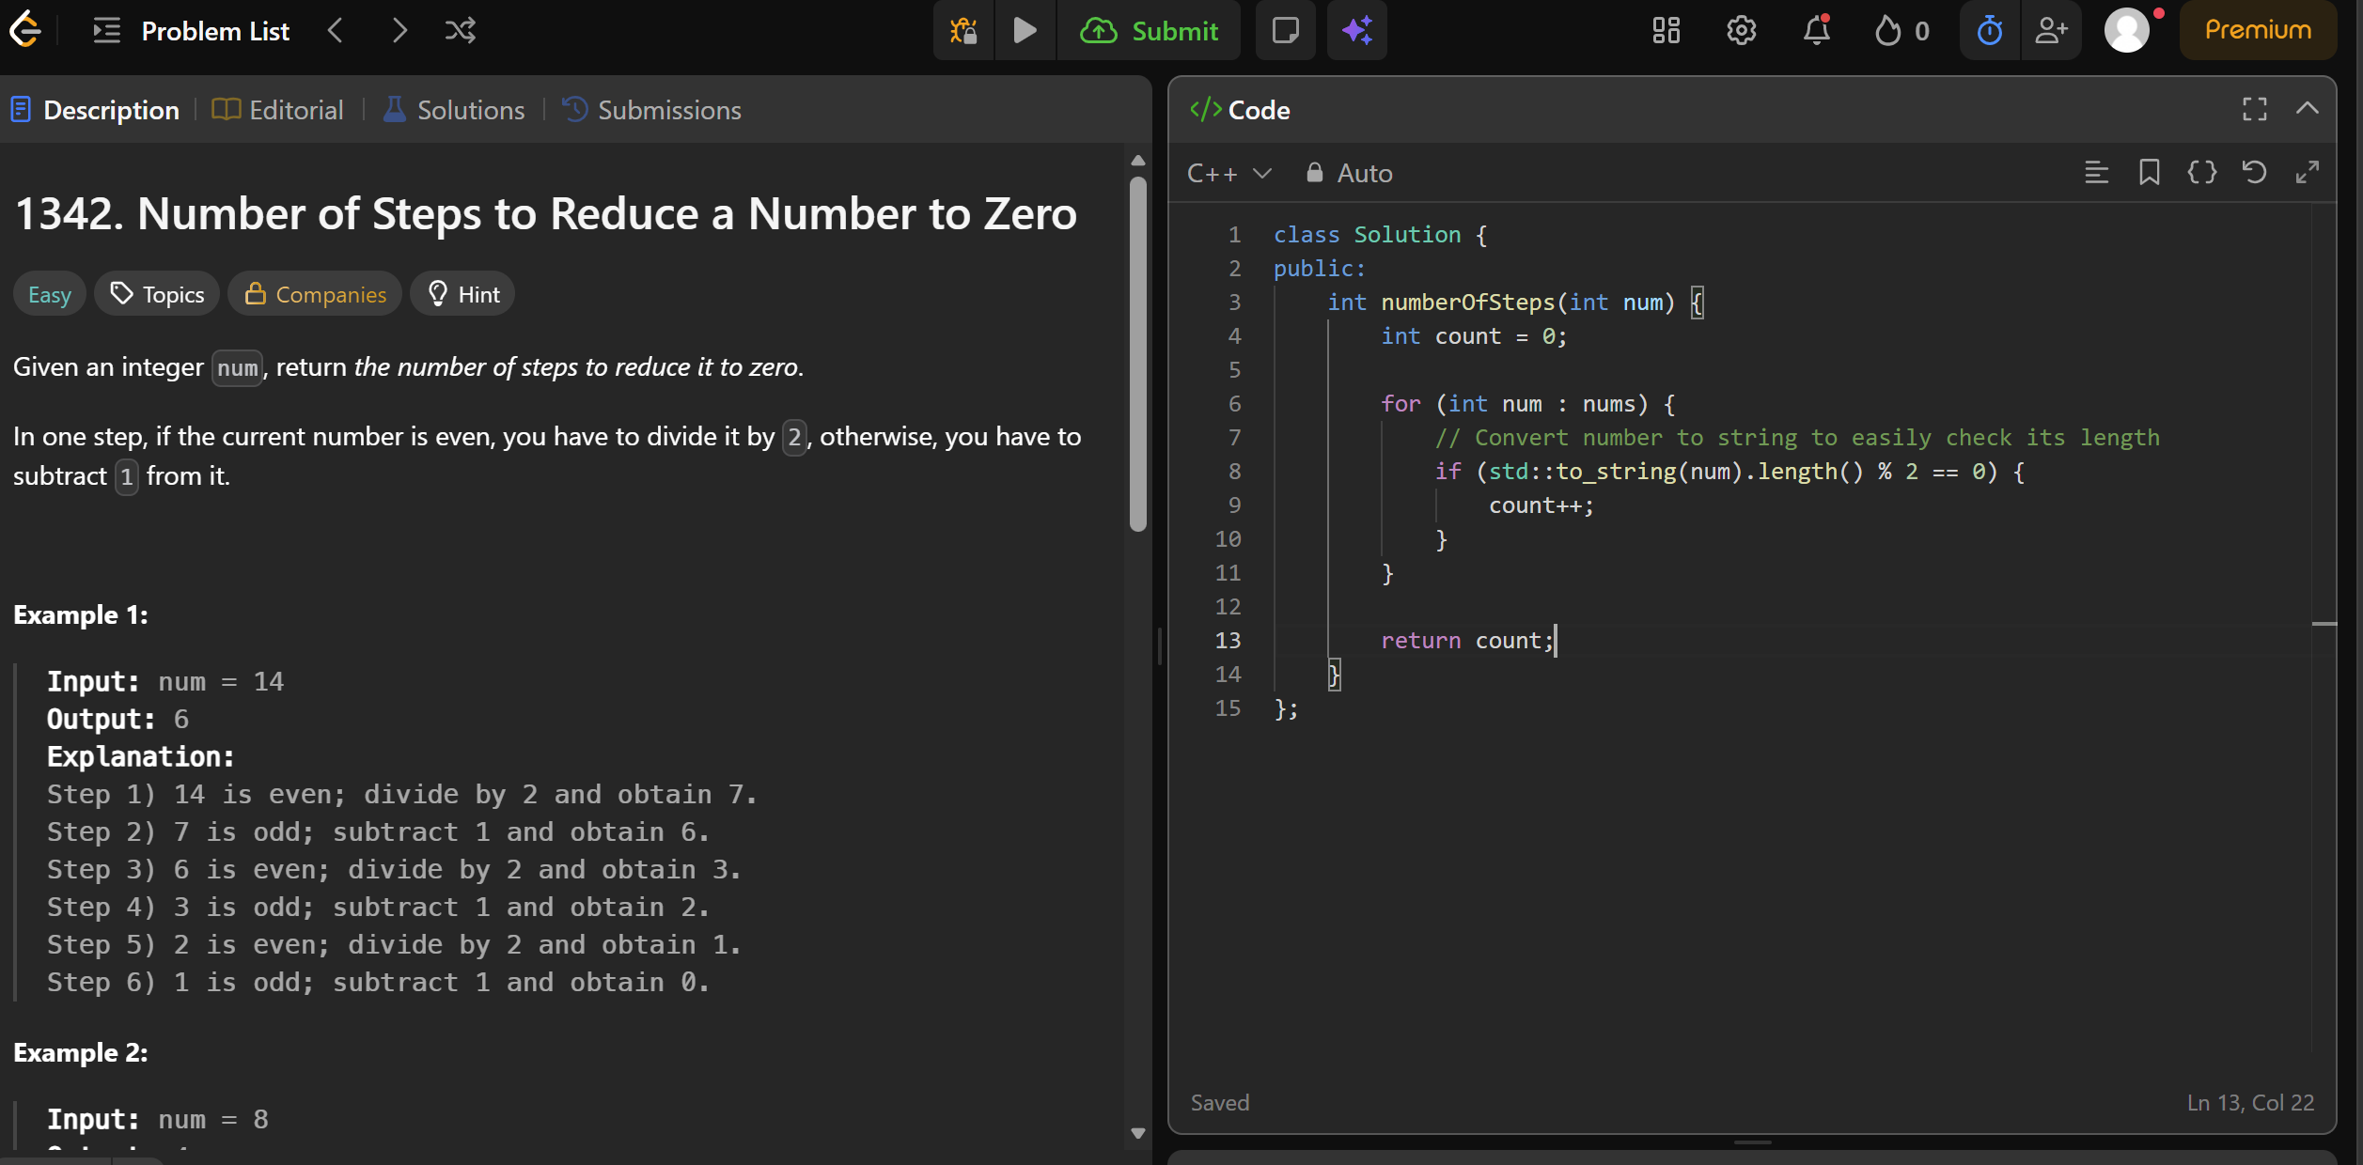
3. https://leetcode.com/problems/count-operations-to-obtain-zero/description/

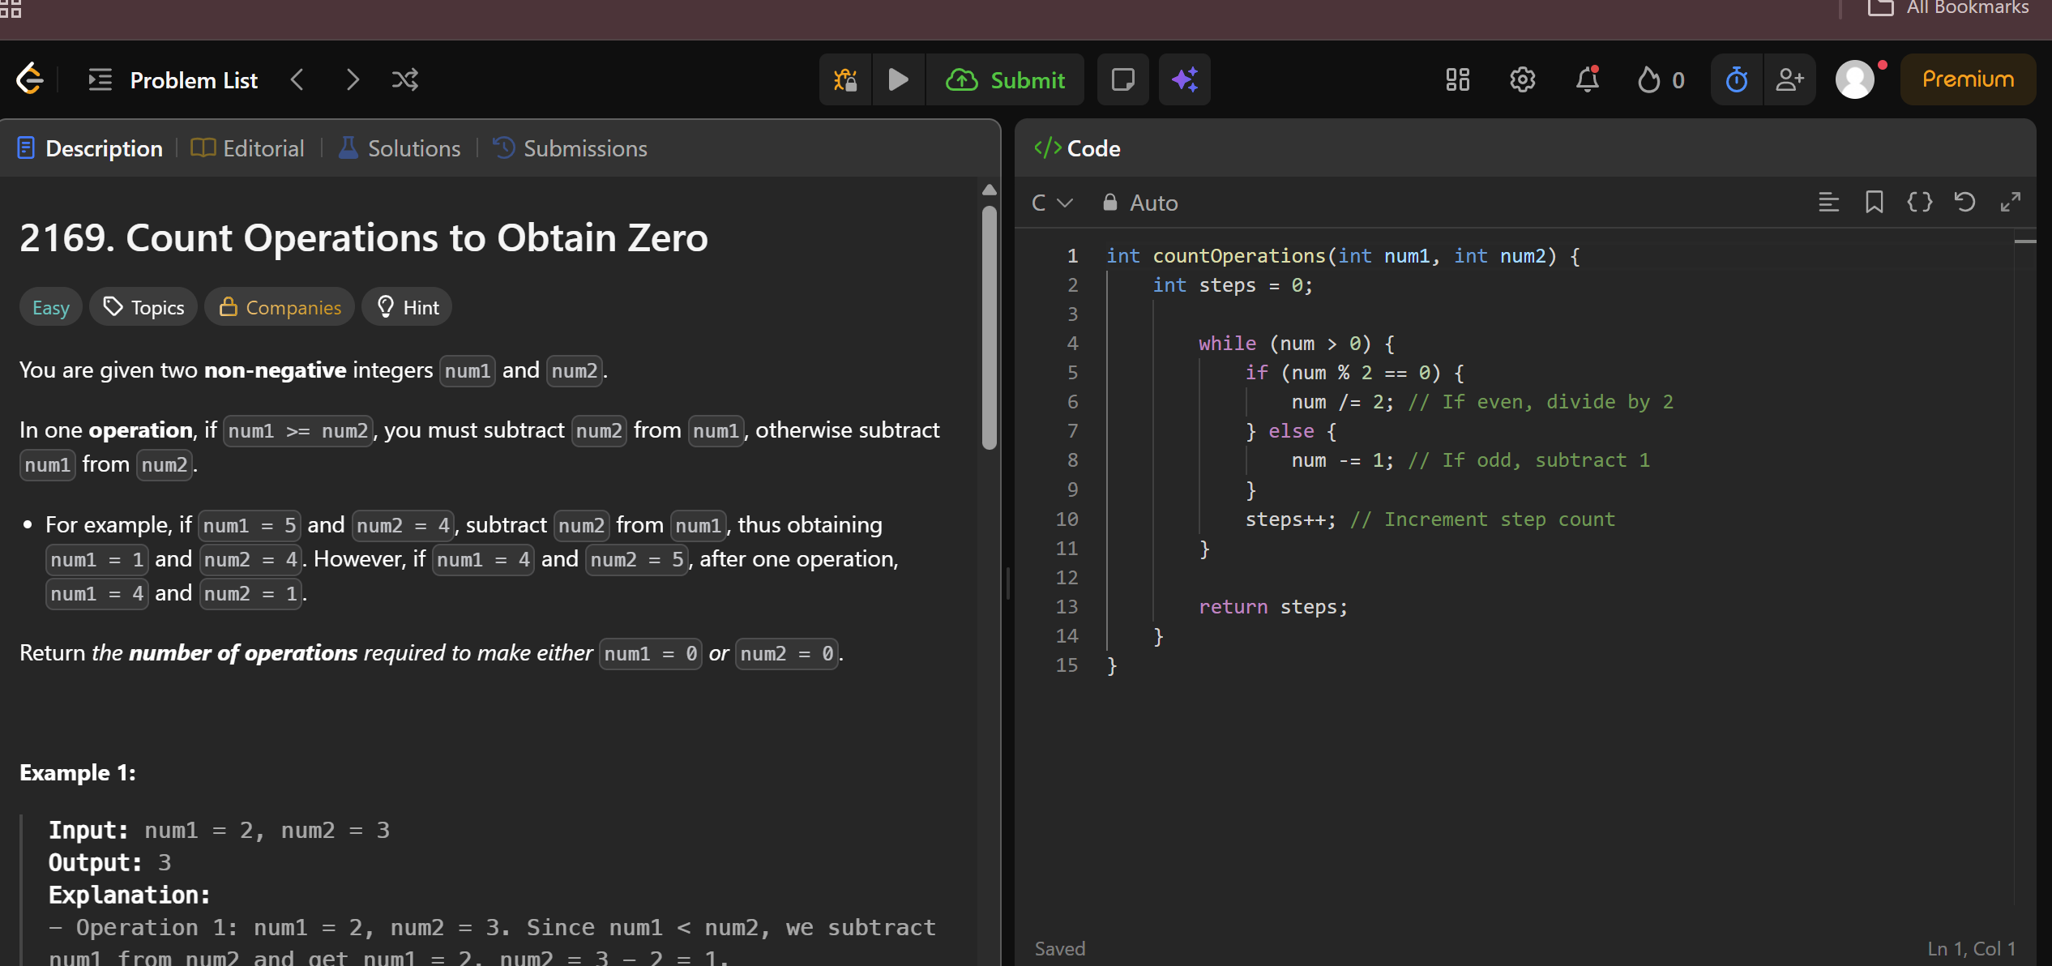
4. https://leetcode.com/problems/count-odd-numbers-in-an-interval-range/description/

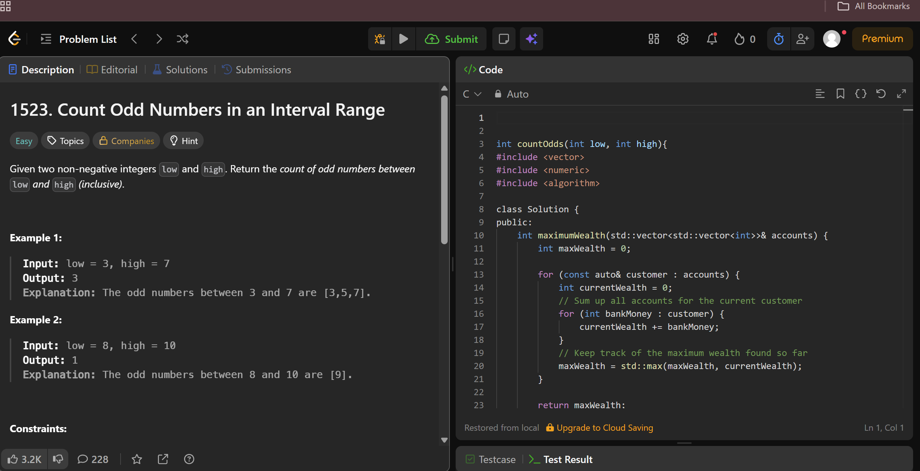
5. https://leetcode.com/problems/sum-multiples/description/

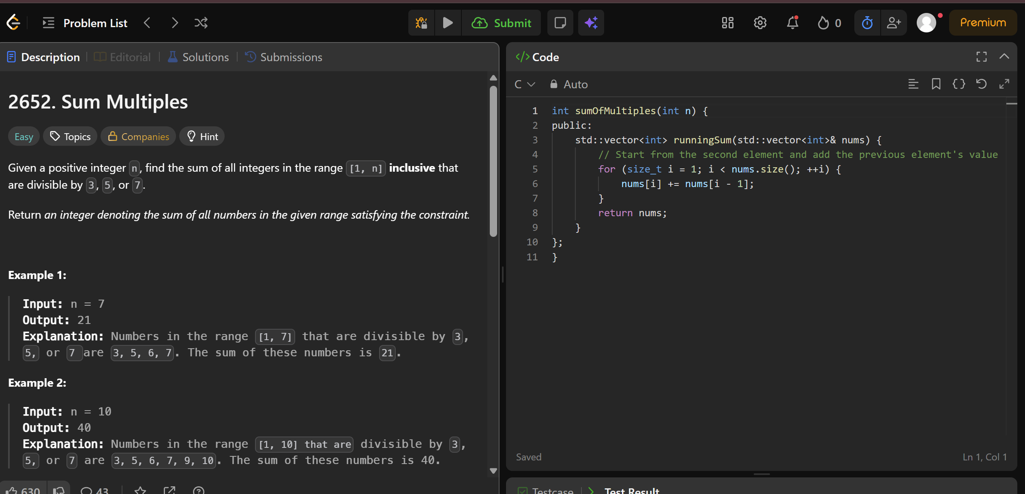
6. https://www.hackerrank.com/challenges/kangaroo/problem



